Week 7 – Hardware Development Update

Document Version Number: 5.0

Date: April 8, 2015

Author: Yu Chen Xu

Hardware Version: 5.0

Goal: To explain the updated version of physical model.

Contents

Launching motor stability 2

# Launching motor stability

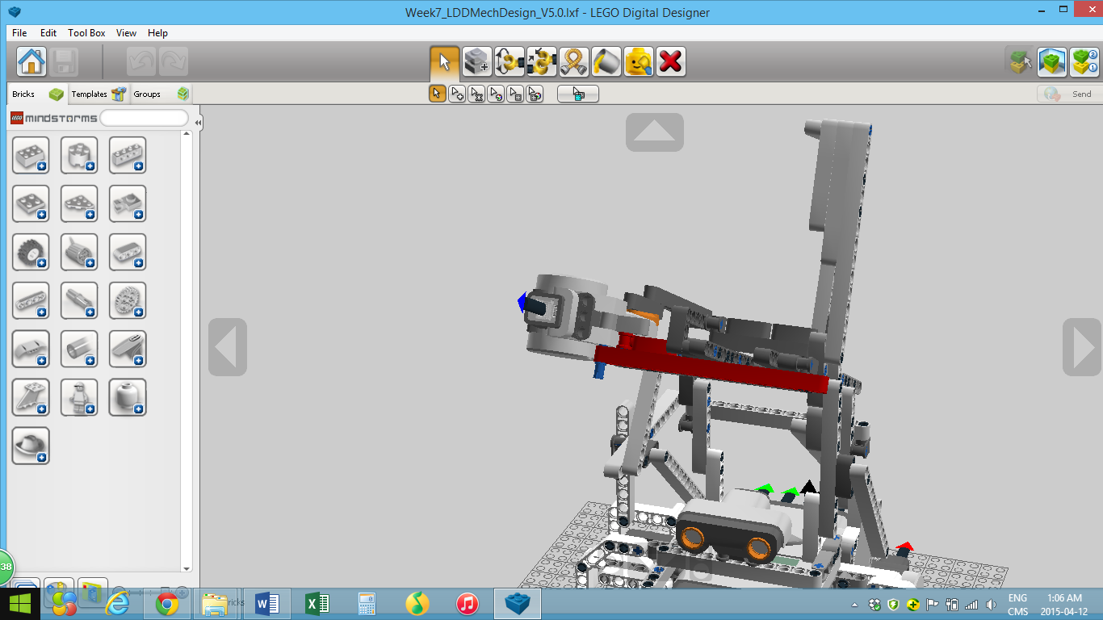

In this week, a modification has been requested by the clients. The target zone is enlarged. Therefore, the distance reached by the ball needs to be increased.

To solve that problem, the mechanical team comes up with the idea to solidify the launching motor with the main structure. The pieces in red are meant to connect the 2 parts and bring stability during shooting. Before, the launching motor is slightly deformed from the main structure when rotating, causing the robot to be a little bit unstable when hitting the ball. Now, every part of the robot is strongly connected when shooting, making the whole structure very stable. As a result, the ball can reach approximately 150cm, an increase of more than 40cm from the last launching test.

# Elastic rubber band

To increase the distance travelled, a better quality elastic band is used.